Assignment 2: Unity maze shortest path using (UCS, BFS, A\*, DFS)

Team Members: Driss Jaidi, Mohammed Chaouni

Blue color: DFS

Cyan color: A\*

Black Color: BFS

Green color: UCS

Snapshot1: A\* using the videos heuristics

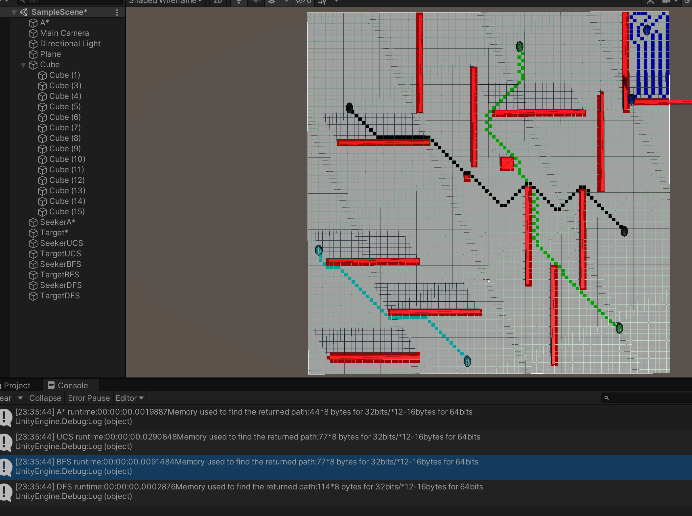

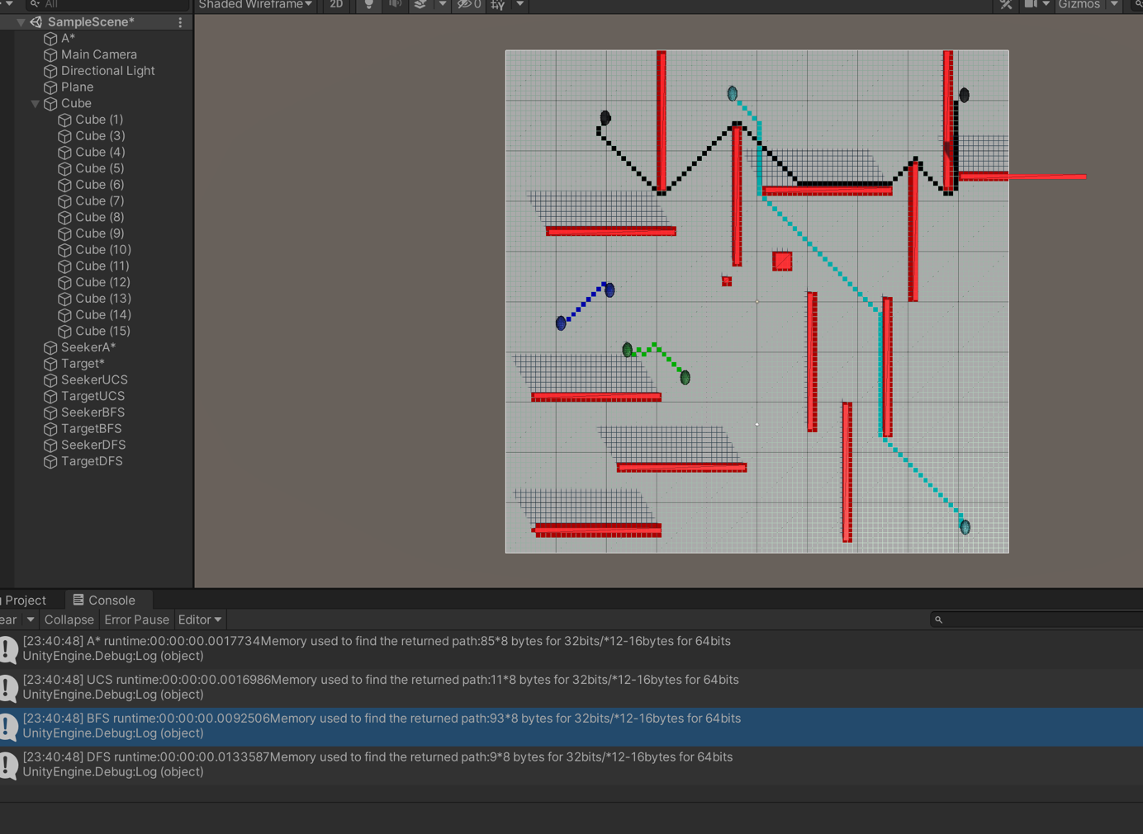

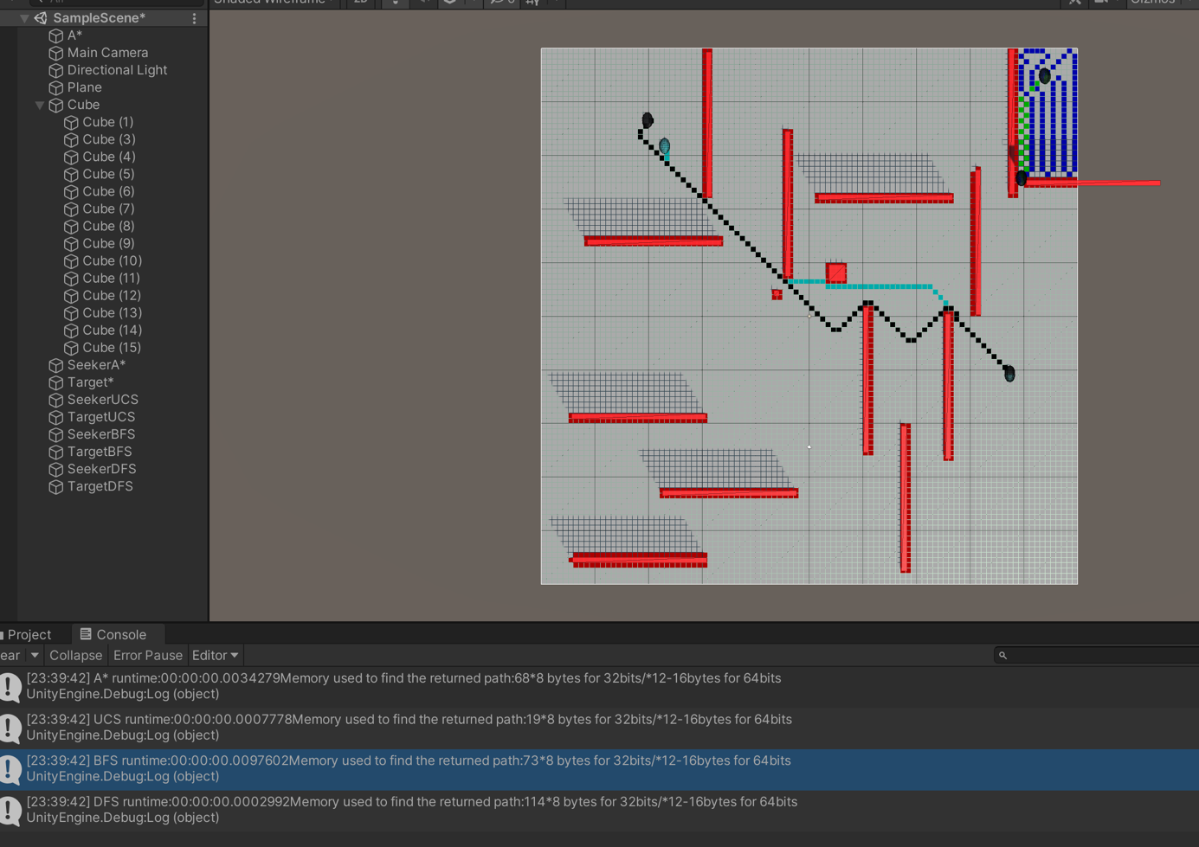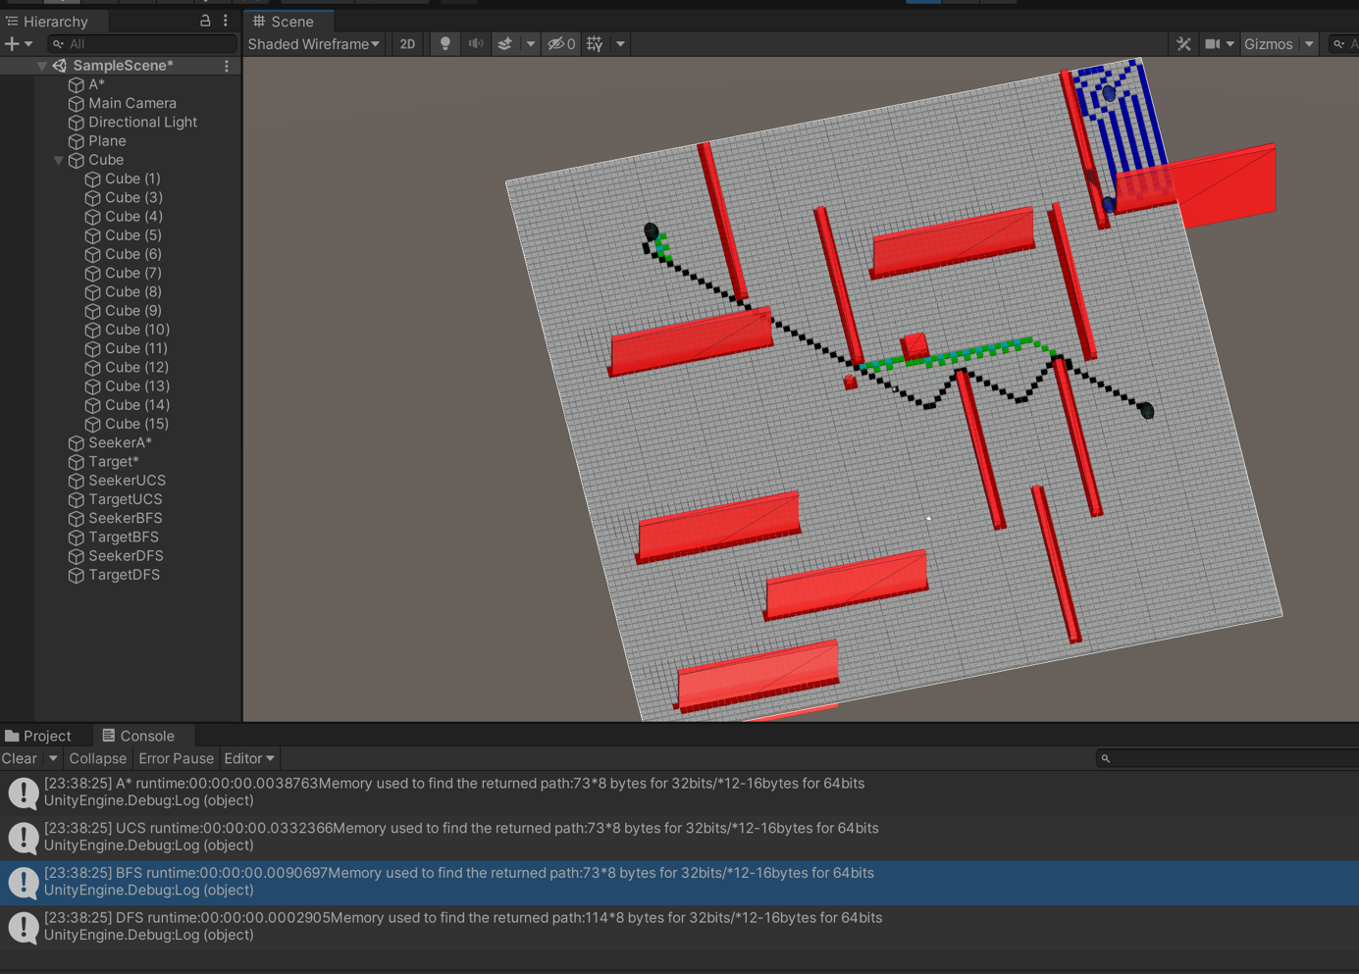

Cc

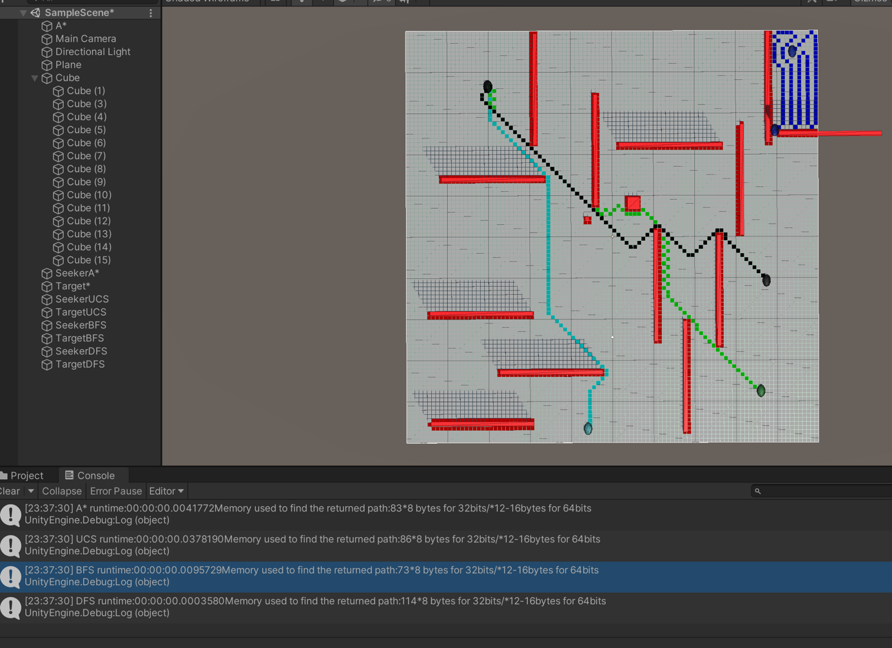

$

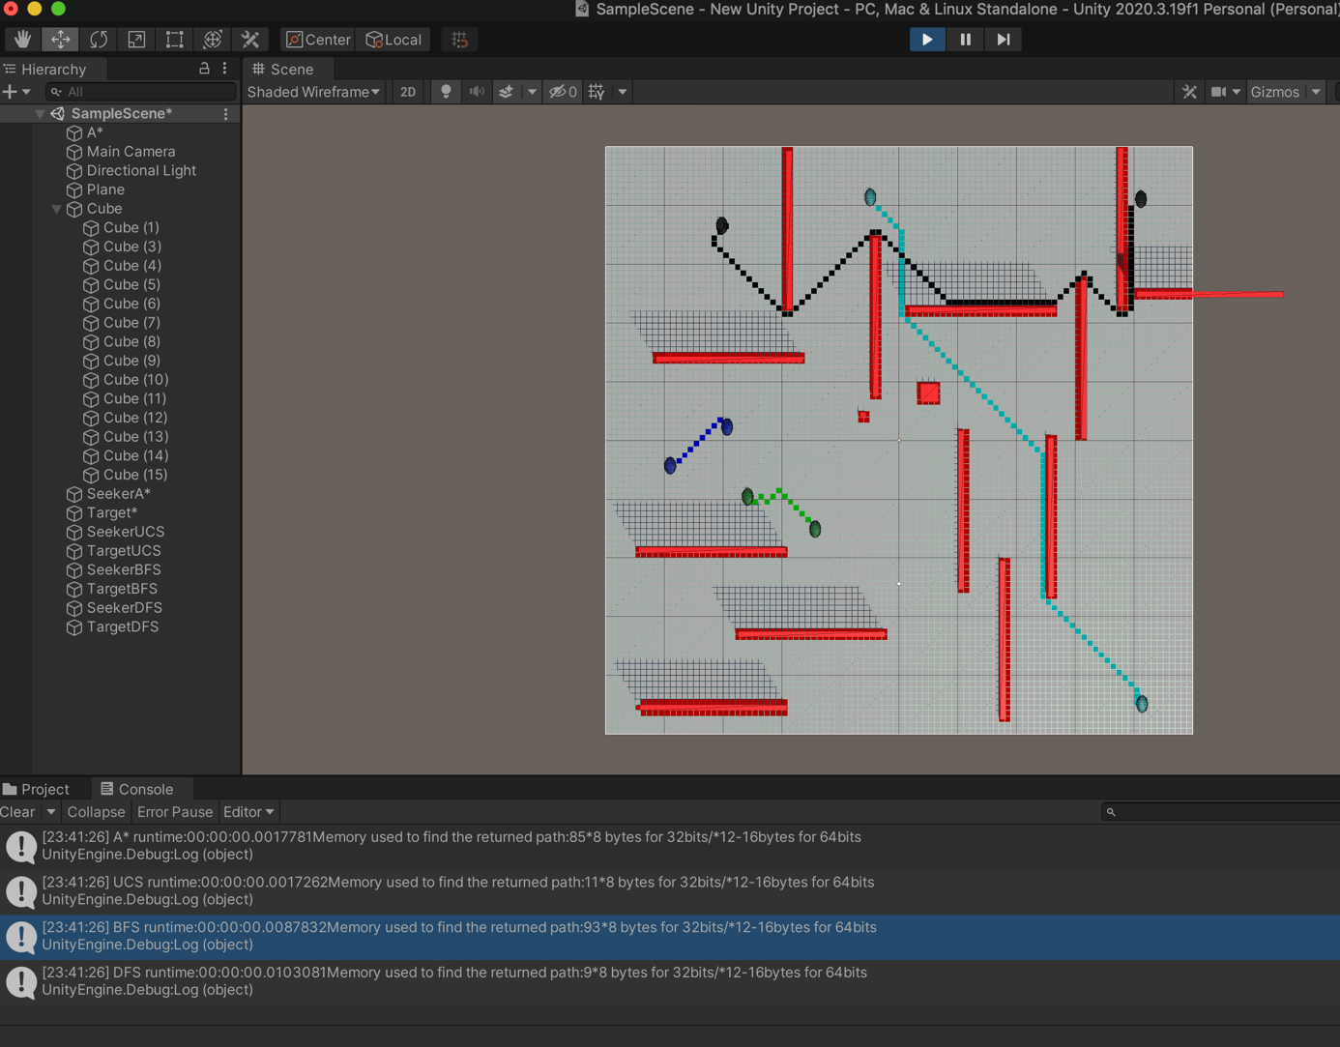

Here the cyan A\* algorithm is using double the original distance:

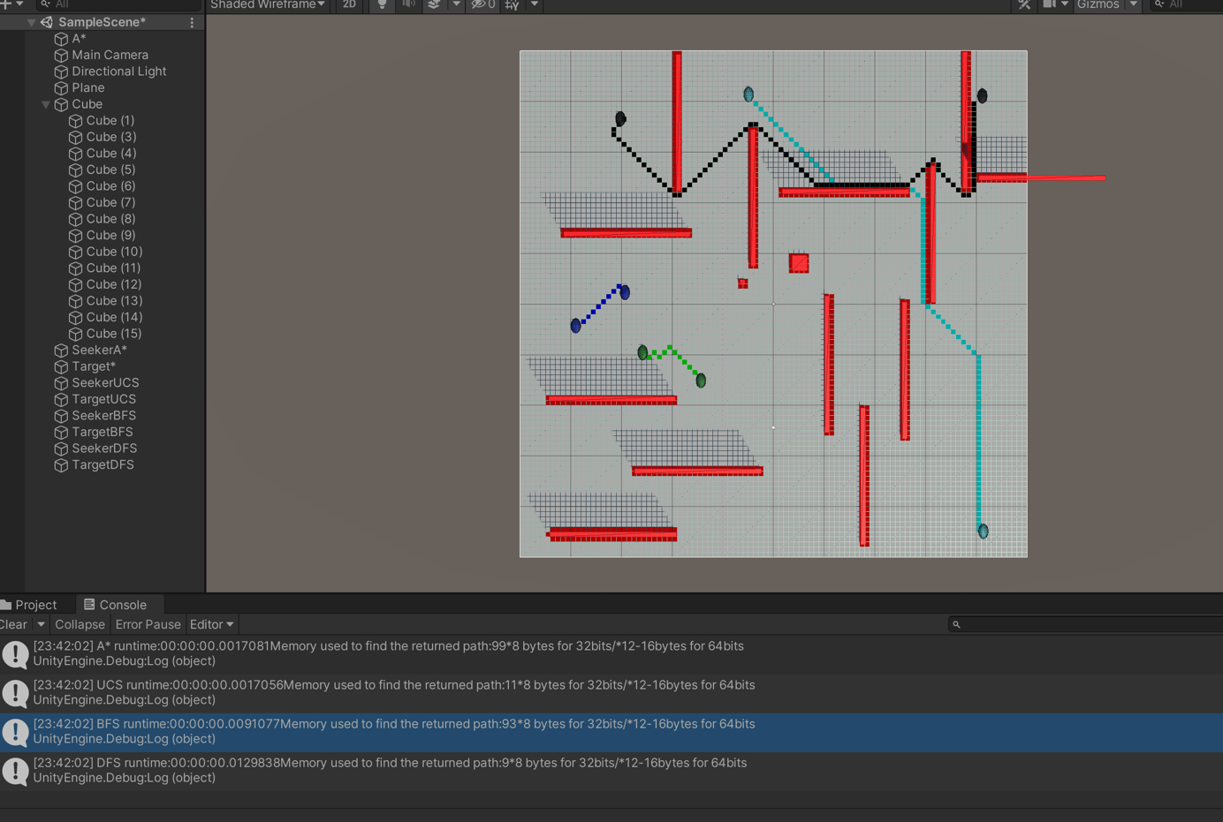

Conclusion :